Vectoring CORDIC

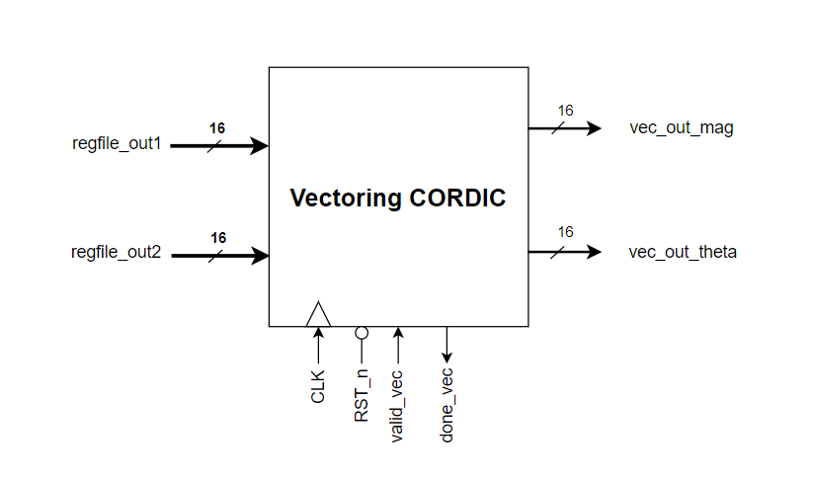

* Function

Vectoring CORDIC is waiting for input pulse from valid_vec signal to start calculating, then it takes two inputs regfile_out1 is the current pivot and regfile_out2 is the element under the current pivot that we want to eliminate it.

It takes around 12 Cycles to end the calculations and then give us vec_out_mag the new pivot and the rotated theta that we will use it later as an input to the rotational CORDIC to evaluate sine and cosine for to evaluate the Q matrix.

After it finish it send a done signal to the FSM to tell it that I had finished.

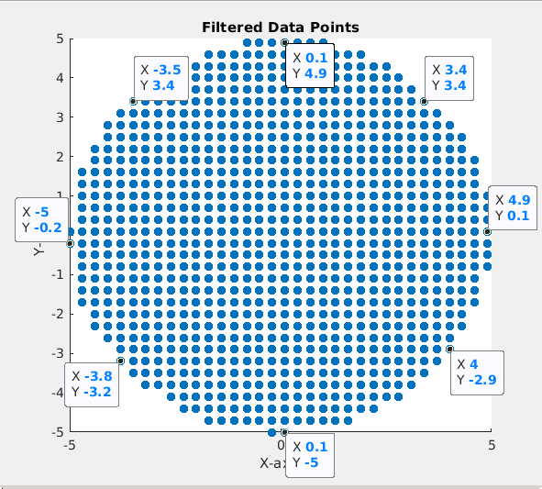

Region of conversion in Vectoring CORDIC

* Inverse block

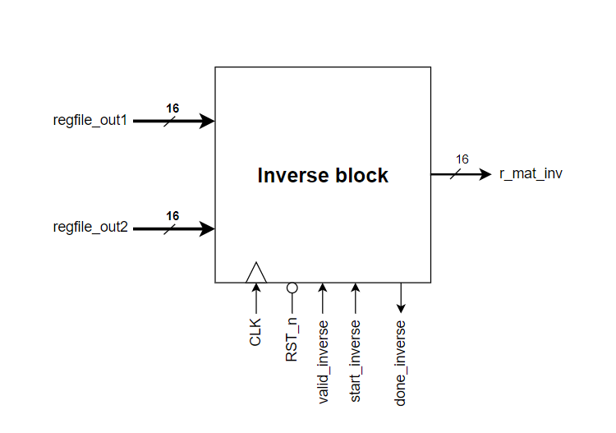

* Function

This block takes the R matrix and evaluate its inverse and the inverse matrix out from the block in 9 clock cycles, valid_inverse pulse tells the block that you have new data at the input ports and then the block takes them in the next clock cycle, start_inverse tell the block to start sending the inverse matrix that had been calculated.

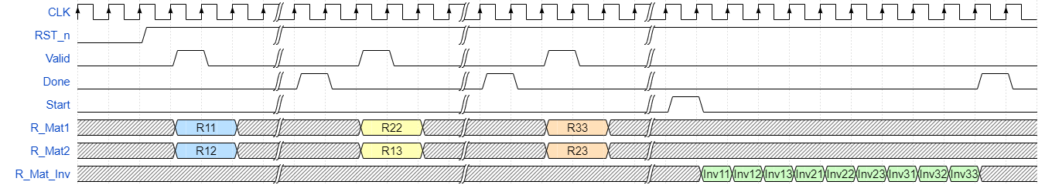

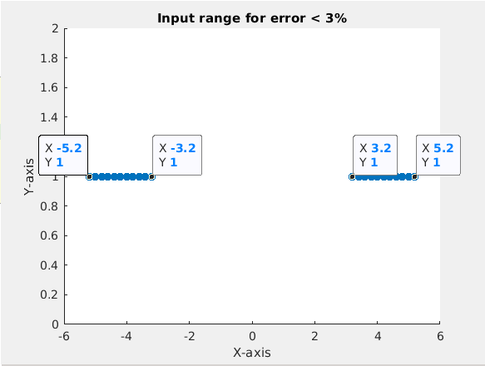

Region of operation for inverse block

